
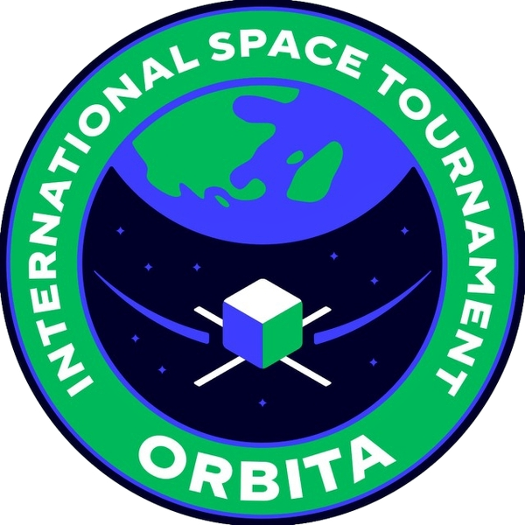

International Space Tournament Orbita

Field | Fill in

Team name
Mentor | Ezoza Yuldosheva
Programer, electrition | Azizbek Nomonjonov

Engineer, CAD designer
Radio Technician / communication | Nurmuhammad Buriev?
Researcher / biology payload specialist | Diyora Mirpulatova

Mission idea brainstorm (Biological) - Diyora
After the table, put a number of ideas and write a description for each idea that you are giving. On the table should be short term. Number 1 on the table is an example. Decision no need to write anything.

# | Mission idea | Question it answers | Main goal of the mission | Sensors / hardware needed | Est. cost | Decision
1 | Ozone profile | How does ozone concentration change with altitude? | Ozone rises sharply above the tropopause (~11–15 km); 22 km reaches the bottom of the ozone layer | Electrochemical O₃ sensor, pump, GPS, logger | ≈ $10

Mission idea brainstorm (Technical) - Azizbek
After the table, put a number of ideas and write a description for each idea that you are giving. On the table should be short term. Number 1 on the table is an example. Decision no need to write anything.

# | Mission idea | Question it answers | Main goal of the mission | Sensors / hardware needed | Est. cost | Decision
1 | Ozone profile | How does ozone concentration change with altitude? | Ozone rises sharply above the tropopause (~11–15 km); 22 km reaches the bottom of the ozone layer | Electrochemical O₃ sensor, pump, GPS, logger | ≈ $10

